Case Study 3

Mohamed Megahed

4/19/2020

# Class Practice - 8

library(ggplot2)  
library(ggforce)  
library(gghighlight)

**1. plot the following graph and label as shown:** *ggplot(economics, aes(date, unemploy)) + geom_line() + labs(title=caption, y=“Unemployment”, x=“Year”)*

ggplot(economics, aes(date, unemploy)) + geom_line() + labs(title="Umeployment rates", y="Unemployment", x="Year",caption = "Umemployment rates")

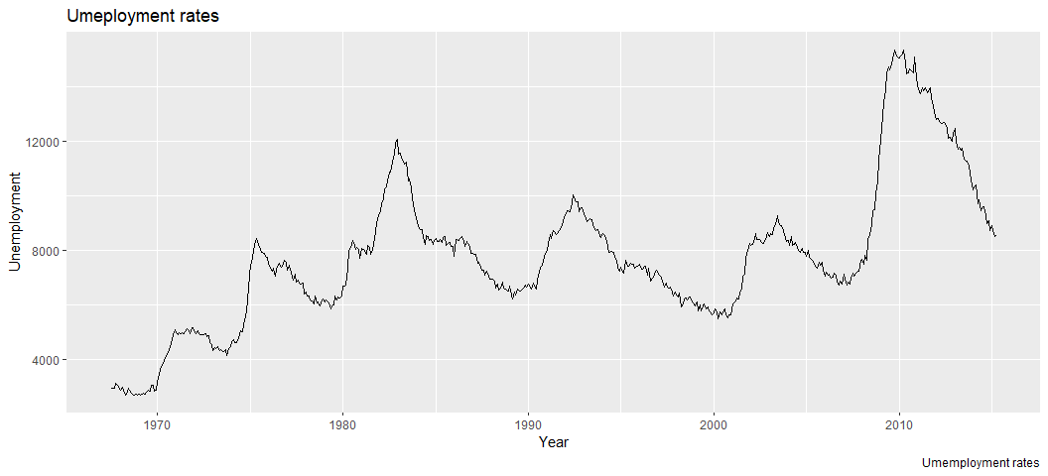

**2 Plot following program to annotate the graph**

p <- ggplot(mpg, aes(displ, cty)) +  
geom_point(data = filter(mpg, manufacturer == "audi"),colour = "red",  
size = 3  
) +geom_point()

## Warning in data.matrix(data): NAs introduced by coercion  
  
## Warning in data.matrix(data): NAs introduced by coercion  
  
## Warning in data.matrix(data): NAs introduced by coercion  
  
## Warning in data.matrix(data): NAs introduced by coercion  
  
## Warning in data.matrix(data): NAs introduced by coercion  
  
## Warning in data.matrix(data): NAs introduced by coercion

## Error in filter(mpg, manufacturer == "audi"): object 'manufacturer' not found

p +  
annotate(  
geom = "curve", x = 3, y = 35, xend = 2.8, yend = 20,  
curvature = .3, arrow = arrow(length = unit(2, "mm"))  
) +  
annotate(geom = "text", x = 3.1, y = 35, label = "Audi", hjust = "left")

## Error in eval(expr, envir, enclos): object 'p' not found

ggplot(mpg, aes(displ, hwy)) +  
 geom_point(colour = "red") +   
 ggforce::geom_mark_ellipse(aes(label = cyl, group = cyl, color = cyl))

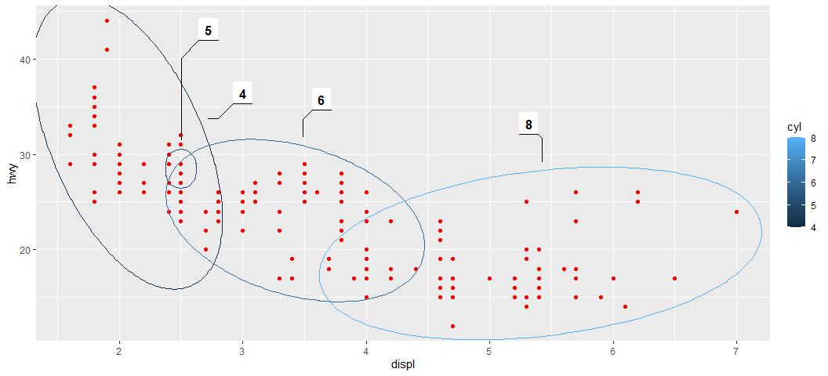

ggplot(mpg, aes(displ, cty,   
 colour = factor(drv))) +  
 geom_point() +   
 gghighlight::gghighlight() +   
 facet_wrap(vars(drv))

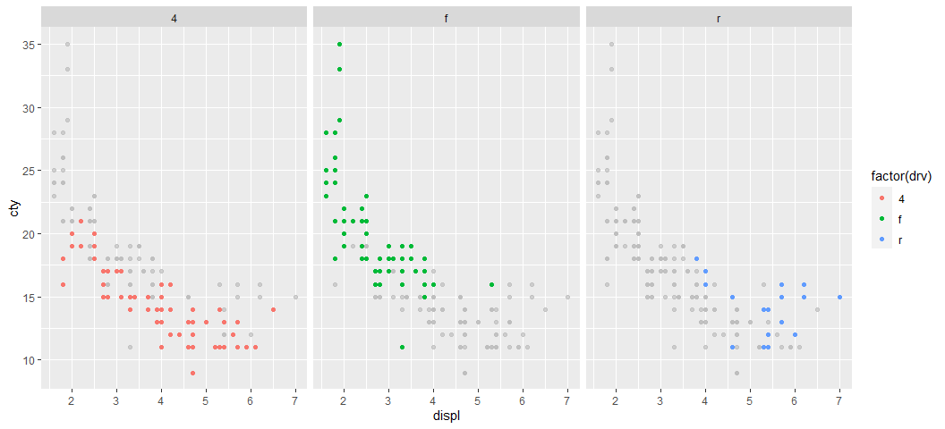

**3 Try following plot**

#Plot 1:  
ggplot(mpg, aes( displ,cty)) +   
 geom_point() +   
 geom_smooth()

## `geom_smooth()` using method = 'loess' and formula 'y ~ x'

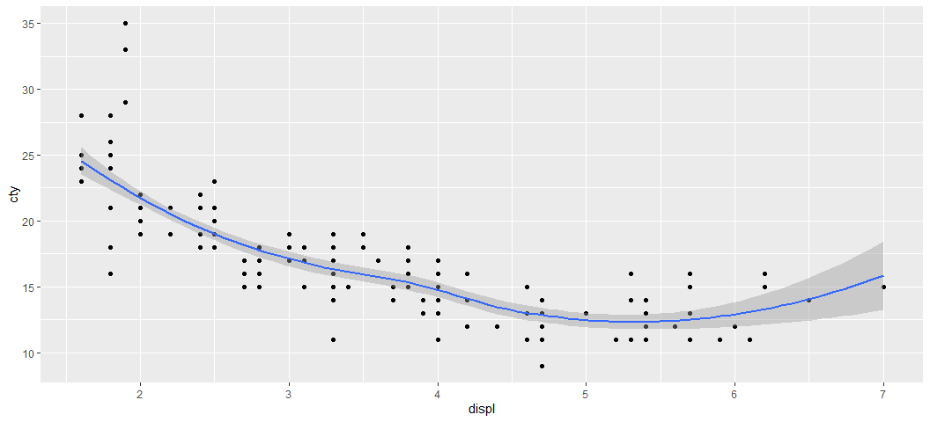

#Plot 2:  
ggplot(mpg, aes(cty,displ)) +   
 geom_point() +   
 geom_smooth()

## `geom_smooth()` using method = 'loess' and formula 'y ~ x'

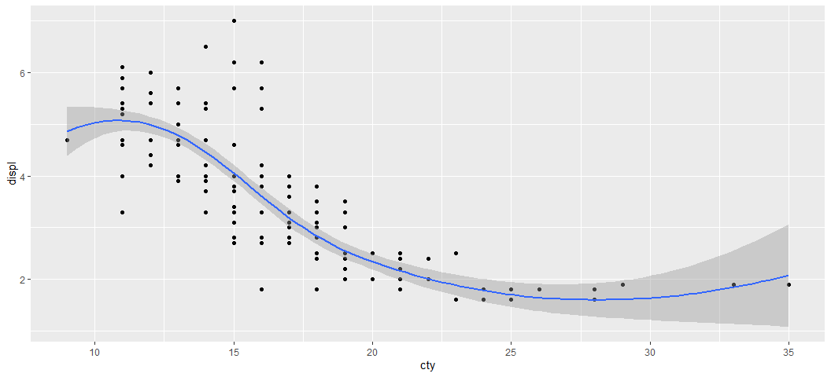

#Plot 3:  
ggplot(mpg, aes(displ, cty)) +   
 geom_point() +   
 geom_smooth() +   
 coord_flip()

## `geom_smooth()` using method = 'loess' and formula 'y ~ x'

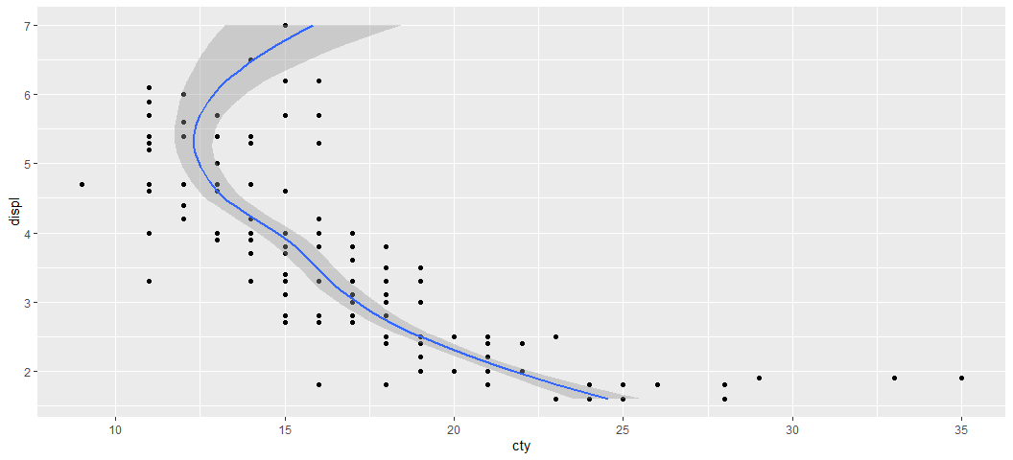

**4. Using “Annotation” discussed earlier, highlight car type “Honda”**

h <- ggplot(mpg, aes(displ, cty)) +  
 geom_point(  
 data = filter(mpg, manufacturer == "honda"),   
 colour = "green",  
 size = 3  
 ) + geom_point() + theme_minimal()

## Warning in data.matrix(data): NAs introduced by coercion  
  
## Warning in data.matrix(data): NAs introduced by coercion  
  
## Warning in data.matrix(data): NAs introduced by coercion  
  
## Warning in data.matrix(data): NAs introduced by coercion  
  
## Warning in data.matrix(data): NAs introduced by coercion  
  
## Warning in data.matrix(data): NAs introduced by coercion

## Error in filter(mpg, manufacturer == "honda"): object 'manufacturer' not found

h + annotate(  
 geom = "curve", x = 4, y = 27, xend = 2.05, yend = 21.5,   
 curvature = .3, arrow = arrow(length = unit(3, "mm"))  
 ) + annotate(geom = "text", x = 4.02, y = 27, label = "Honda", hjust = "left",colour = "red")

## Error in eval(expr, envir, enclos): object 'h' not found

**5. Using ggforce() to highlight the “Class” of cars on “City” mileage based on engine (displ)**

ggplot(mpg, aes(displ, cty)) +  
 geom_point(size = 1, colour = "blue") + theme_minimal() +  
 ggforce::geom_mark_ellipse(aes(label = class, group = class,color = class))

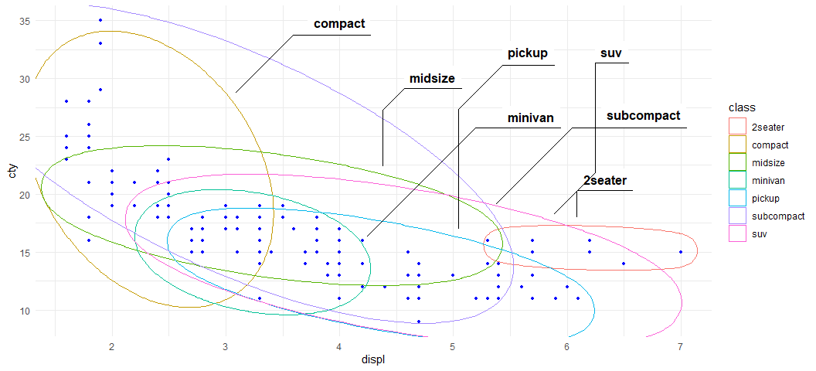

**6. Using gghighlight() cluster “transmission” type**

ggplot(mpg, aes(displ, cty,   
 colour =factor(trans))) +  
 geom_point(size = 1) + theme_minimal() +  
 gghighlight::gghighlight() +   
 facet_wrap(vars(trans))

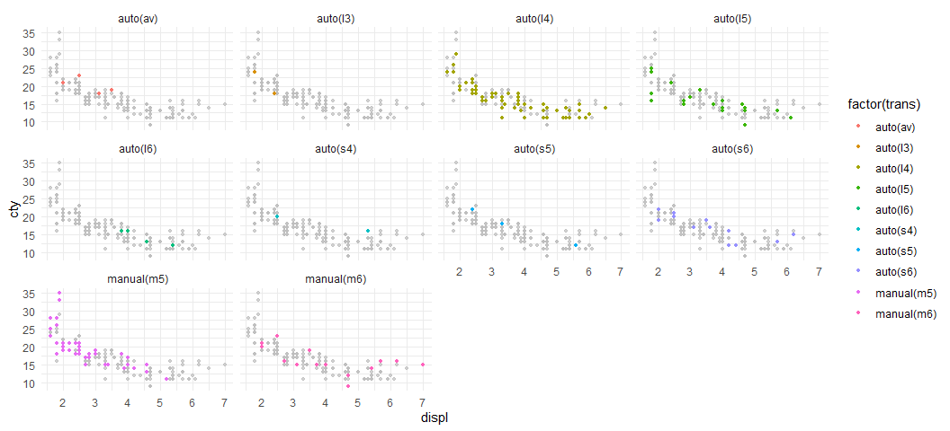

# Class Practice - 9

### Building layers:

*1. Execute the following commands to build the first layer:* *p<-ggplot(mpg, aes(displ, hwy))*

p<-ggplot(mpg, aes(displ, hwy))  
p

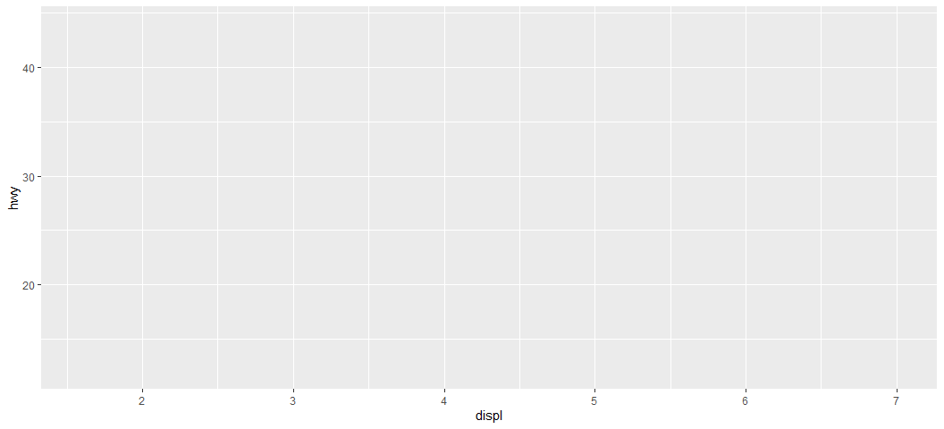 **2 Add aesthetics to the plot:**

p + layer(  
 mapping = NULL,   
 data = NULL,  
 geom = "point",   
 stat = "identity",  
 position = "identity"  
)

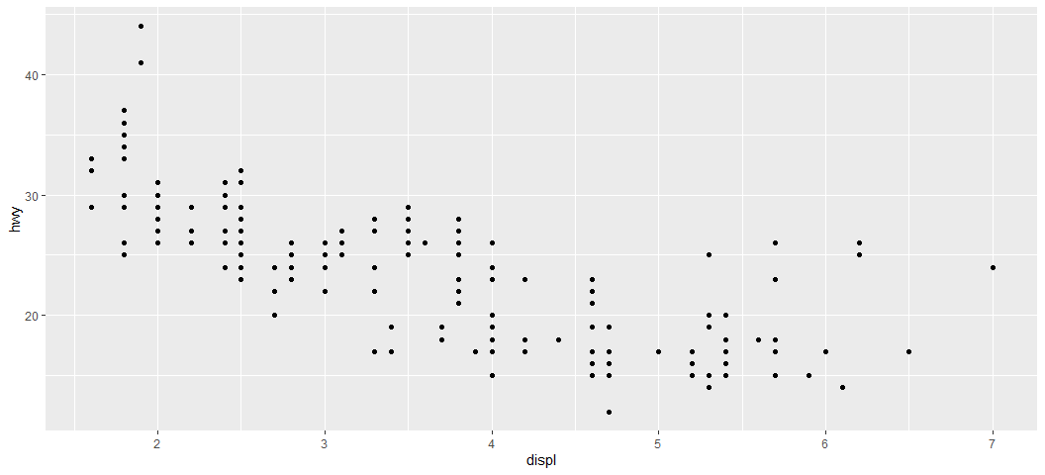

**3. Can you change “colour” of points?**

ggplot(mpg, aes(displ, hwy))+ layer(  
 mapping = NULL,   
 data = NULL,  
 geom = "point",   
 stat = "identity",  
 position = "identity",  
)+ geom_point(size = 1, colour = "red")

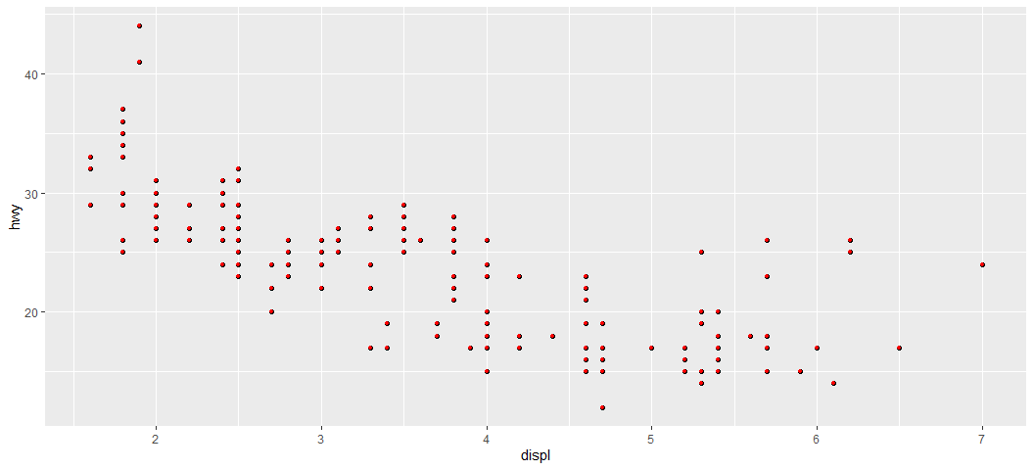

**4. Fit the line to the data points by executing following ggplot() program:**

ggplot(mpg, aes(displ, hwy, colour = class)) +   
 geom_point() +   
 geom_smooth(method = "lm", se = FALSE) +  
 theme(legend.position = "none")

## `geom_smooth()` using formula 'y ~ x'

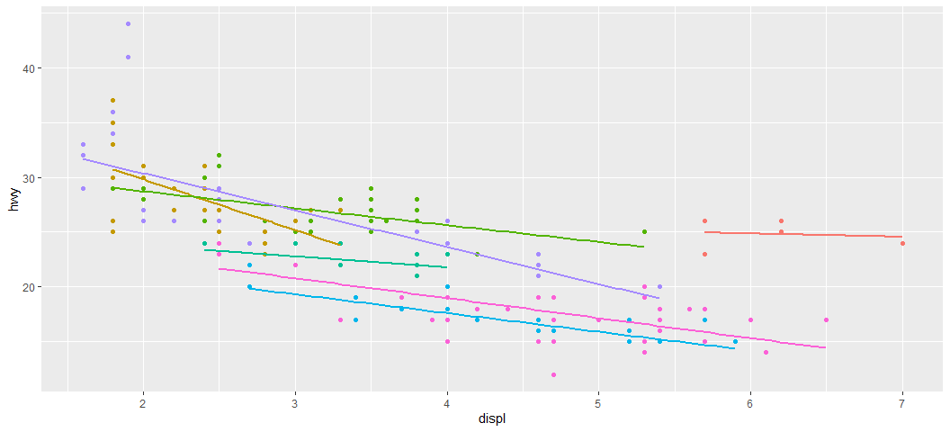

**5. Add two methods in the geom_smooth**

ggplot(mpg, aes(displ, hwy)) +   
 geom_point(aes(colour = class)) +   
 geom_smooth(method = "lm", se = FALSE) +   
 theme(legend.position = "none")

## `geom_smooth()` using formula 'y ~ x'

